Disability Rights & the Family Regulation System

What Is Family Policing?
“The child welfare system is a powerful state policing apparatus that functions to regulate poor and working-class families—especially those that are Black, Latinx, and Indigenous—by wielding the threat of taking their children from them.” — Dorothy Roberts, “Torn Apart” (2022)

How the Dependency Process Works
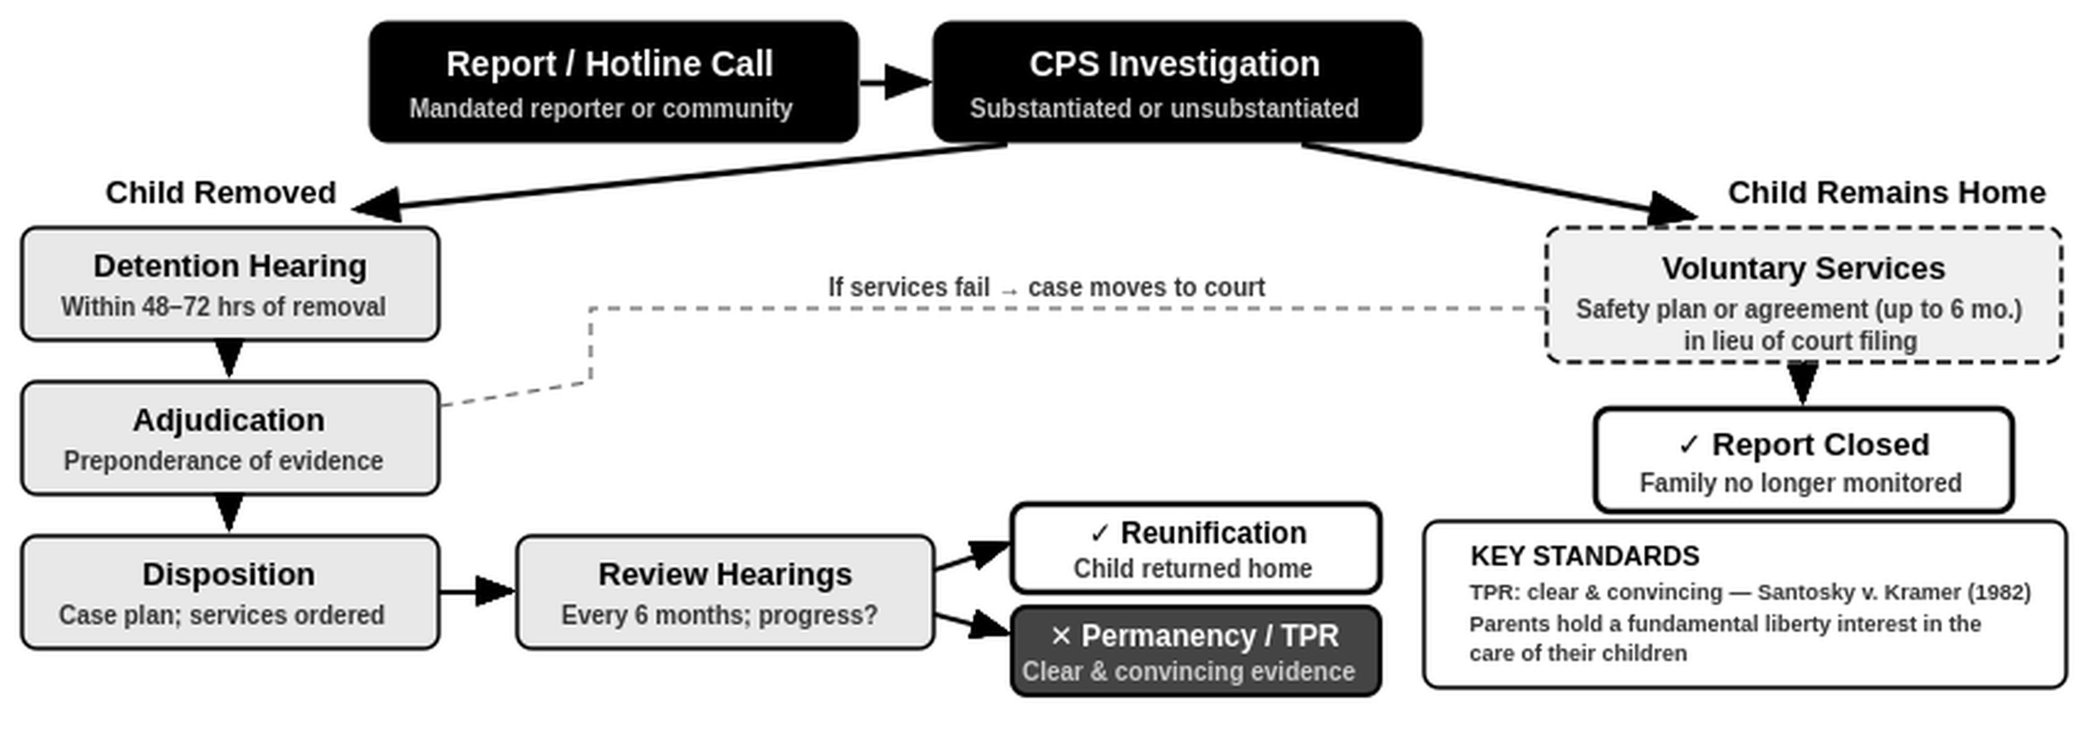

Does the ADA Protect Parents in Family Court?
The ADA says government agencies can’t discriminate against people with disabilities. Courts agree this applies to the child welfare context — but they are deeply split on what it covers.

Some courts have applied the ADA or a state equivalent rule applies to the dependency process and require that reunification services be tailored to a parent’s disability. Other courts have said that the ADA does not apply, leaving parents with little recourse when disability discrimination occurs during the dependency and reunification process.

Cases Applying ADA to Reunification Services (Growing Minority Rule)
- Utah — K.C. (Utah 2015): Reunification services are “services provided by a public entity” under Title II and must be ADA-compliant.

- Michigan — In re Terry (2000) recognized the split in a single opinion: the ADA does not apply to TPR proceedings, but reunification services had to comply with ADA. Hicks/Brown (2017) built on this: if the agency never accommodated the disability, it can’t claim “reasonable efforts.”

Cases Holding ADA Does Not Apply to Termination Proceedings (Current Majority Rule)
- Core reasoning: TPR proceedings are “for the benefit of the child, not the parent” and are not “services, programs, or activities of a public entity”. The ADA provides no defense to termination and creates no special obligations for courts. M.C. v. DCF (Fla. 2000).

States following: Florida (M.C. v. DCF, 2000); Rhode Island (Kayla N., 2006); Connecticut (Antony B., 1999); Louisiana (B.K.F., 1997); North Carolina (C.M.S.. 2007; A.P., 2022); Pennsylvania (J.J.L., 2016); Illinois (Jeanette L., 2017).

Fighting Back
- Punishing Recovery (NY): A father lost his parental rights because a judge decided his doctor-prescribed methadone dose was “too high”, even though he was following medical advice. The ACLU filed a brief saying this is disability discrimination. Matter of Jorge C. (2025).¹

- Algorithms That Discriminate (PA): Allegheny County uses a computer program to score families reported to the hotline. An ACLU audit found it uses mental health and addiction records to raise scores, thus punishing families Black and disabled families hardest.²

- Medication Denied Behind Bars (NC): A woman in a state prison was given addiction medication while pregnant but the prison took it away after birth. She was also shackled during delivery. The ACLU joined her case. Edwards v. NCCIW (2025).³

¹ ACLU Urges New York Appeals Court to Reverse Termination of Parental Rights Based on Opioid Treatment Stereotypes, ACLU (July 2, 2025), https://www.aclu.org/press-releases/aclu-urges-new-york-appeals-court-to-reverse-termination-of-parental-rights-based-on-opioid-treatment-stereotypes

² The Devil Is in the Details: Interrogating Values Embedded in the Allegheny Family Screening Tool, ACLU (2023), https://www.aclu.org/the-devil-is-in-the-details-interrogating-values-embedded-in-the-allegheny-family-screening-tool

3 ACLU Joins Appeal of Incarcerated Woman Shackled During Childbirth and Deprived of Medication, ACLU (Mar. 4, 2025),
https://www.aclu.org/press-releases/aclu-joins-appeal-of-incarcerated-woman-shackled-during-childbirth-and-deprived-of-medication

